

**CALL FOR AWARDING GRANTS TO CIVIL SOCIETY ORGANISATIONS – FIRST PHASE 2022**

**COMMUNITY INVESTMENT PLATFORM**

*Deadline for submission of the applications: 22.04.2022 by 16:00 hrs.*

Please send your applications to: info@cip.mk

**ANNEX 4: STATEMENT ON DOUBLE FUNDING**

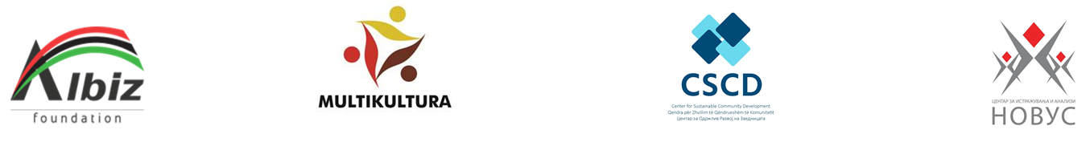

I hereby declare that:

The applicant: _______________________________________________________________________

(name of the CSO)

**Please circle only one of the proposed two options:**

A) has not received

a grant for the submitted project from public sources within the public calls announced by government agencies, municipalities, other public institutions, European funds or other local or international funds.

or

B) has applied

for funding of the project, but the evaluation of the project is **still ongoing.** Please state:

___________________________________________________________________________________

(the name of the institution and the public call within which the project has been submitted)

In case of a positive result from the procedure, Albiz Foundation should be immediately informed in order to implement measures for prevention of the possibility for double funding.

I hereby declare, under legal and material responsibility, that all information in this statement is correct, true and complete.

|  |  |
| --- | --- |
| Legal representative of the organization: |  |
| Date: |  |
| Signature and stamp: |  |