

**CALL FOR THE AWARDING OF GRANTS TO CIVIL SOCIETY ORGANIZATIONS - FIRST PHASE 2022**

**COMMUNITY INVESTMENT PLATFORM**

*Deadline for submission of the applications: 22.04.2022 by 16:00 hrs.*

Please send your applications to: info@cip.mk

**ANNEX 5: CHECKLIST**

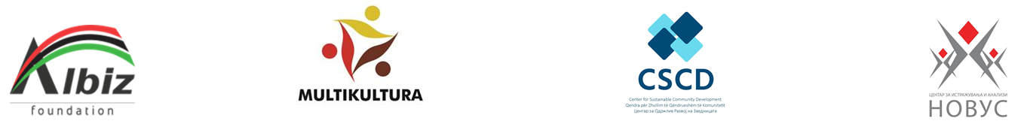

After completing this application, as well as providing the necessary additional documentation (annexes), please fill in this checklist to confirm that the application is complete and in accordance with the criteria and the requirements. Please mark all the criteria and requirements that are met.

|  |  |  |
| --- | --- | --- |
| **Name of the organization:** | | |
| **Annexes** | | |
| Annex 1 – Application Form (word format and scanned last page with a signature and stamp) |  | (Remarks, if any) |
| Annex 2 – Budget Form (excel) |  |  |
| Annex 3 – List of references for projects implemented in the last 3 years (word format) |  |  |
| Annex 4 - Statement of double funding (scan with a signature and stamp) |  |  |
| Annex 5 - Checklist (word format) |  |  |
| Annex 6 – Membership Application Form (scan with a signature and stamp) |  |  |
| **Other documents** | | |
| Copy of the current status, not older than 6 months before the date of publication of the call (scan) |  |  |
| Narrative and financial report on the operation of the organization for 2021 or links to them (optional) (scan) |  |  |
| CVs of the project team (word or PDF) |  |  |
| Copy of the audit report for 2020 (optional) (word or PDF) |  |  |
|  |  |  |