

**CALL FOR THE AWARDING OF GRANTS TO CIVIL SOCIETY ORGANIZATIONS - FIRST PHASE 2022**

**COMMUNITY INVESTMENT PLATFORM**

*Deadline for submission of the applications: 22.04.2022 by 16:00 hrs.*

Please send your applications to: info@cip.mk

**ANNEX 6: MEMBERSHIP APPLICATION FORM**

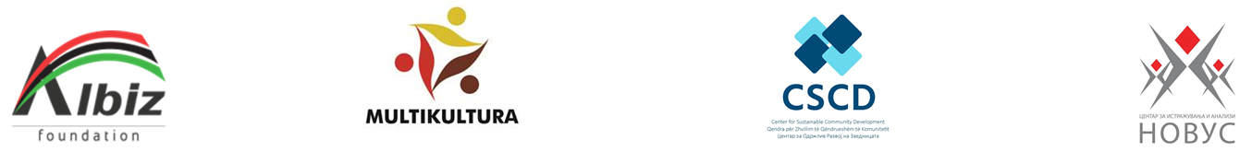

**APPLICATION FOR MEMBERSHIP**

**IN THE COMMUNITY INVESTMENT PLATFORM**

|  |  |
| --- | --- |
| Name of the organization: |  |
| Address of the organization: |  |
| Town: |  |
| Telephone: |  |
| E-mail: |  |
| Website: |  |
| Mission of the organization: |  |
| Sector of operation: |  |
| Region of operation: |  |
| Contact person: |  |
| Telephone: |  |
| E-mail: |  |

Place for stamp Responsible person:

________________